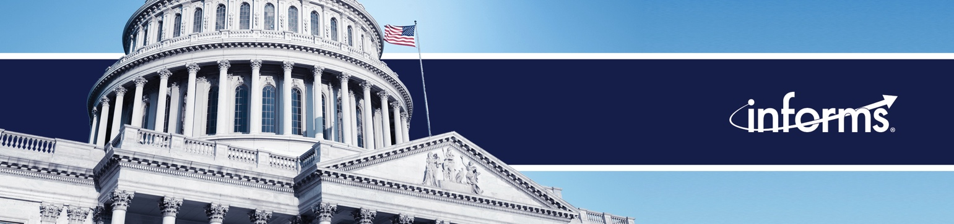

Weekly News Update: 8/1/23

Rounding out the month of July, we’ve touched on some new topics in the media related to the Hollywood strike, updates from Ukraine and new angles related to artificial intelligence. We are utilizing several new members in our outreach and seeing great results.

Why is Russia targeting Ukraine ports, and what does it mean for global food security?  July 21, 2023  Member: Anna Nagurney | ‘Enough is enough and we demand more’: Sheryl Lee Ralph, ‘Abbott Elementary’ star brings the SAG-AFTRA strike to Philly  July 20, 2023  Member: Rahul Telang
Why Russia pulled out of its grain deal with Ukraine – and what that means for the global food system  July 19, 2023  Member: Anna Nagurney | Hollywood Plunges Into All-Out War on the Heels of Pandemic and a Streaming Revolution  July 17, 2023  Member: Rahul Telang

Members in the News

Are Shared Medical Appointments the Key to Solving Global Healthcare Shortages?  July 21, 2023  Member: Ryan Buell | An Empty Threat?  July 21, 2023  Member: Anna Nagurney
How Sustainable Is Grocery Delivery?  July 20, 2023  Member: Destenie Nock | Anna Nagurney, professor of supply chains, logistics and economics at the University of Massachusetts Amherst, explains to Moore In The Morning what is…  July 18, 2023  Member: Anna Nagurney
Sheldon H. Jacobson: An AI Bill of Rights would be unenforceable and may do more harm than good  July 18, 2023  Member: Sheldon Jacobson | Strikes rock Hollywood hit by streaming revolution, pandemic standstill  July 17, 2023  Member: Rahul Telang
The Dirty Secret Behind Companies’ Carbon-Emissions Disclosures  July 17, 2023  Member: Christopher Tang | Anna Nagurney Delivers Keynote Talk at IFORS Conference in Santiago, Chile  July 17, 2023  Member: Anna Nagurney
Hollywood plunges into all-out war on the heels of pandemic and a streaming revolution  July 17, 2023  Member: Rahul Telang | As Chemotherapy Drug Shortage Continues, Unimaginable Decisions and Lacking Accountability Reign  July 14, 2023  Member: Tinglong Dai
Heard on the Street – 7/12/2023
July 12, 2023
Member: Tinglong Dai

PRESIDENT OF KYIV SCHOOL OF ECONOMICS VISITS UMASS AMHERST

PRESIDENT OF KYIV SCHOOL OF ECONOMICS VISITS
Press Releases

7/17: Draining 401(k) Accounts When Changing Jobs: The Hidden Time Bomb Undermining Retirement Savings

7/31: Decision Science Digest: July 31, 2023

