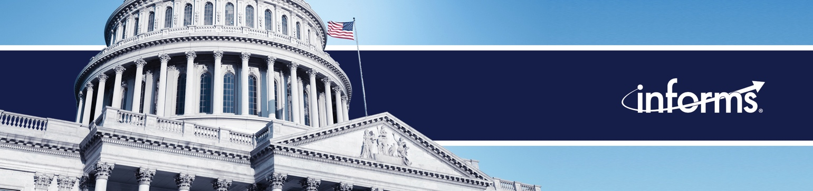

INFORMS Members in the News - Weekly News Update: 9/25/23

A very strong last few weeks for INFORMS members in the news. We tracked several top tier media placements showcasing our members on topics related to the economy, supply chain, UAW strike, artificial intelligence, and elections. We also had numerous placements in trade publications and local media.

Christopher Tang: A collapse of China’s economy would hurt many countries, including the US  September 25, 2023  Christopher Tang | Car prices could surge 10% or more as UAW strike enters second week  September 19, 2023  Rob Handfield
TikTok Rolls Out Labels for AI-Generated Content  September 19, 2023  Cynthia Rudin | Ghost Helps Brands Unload  September 18, 2023  Christopher Tang
United Auto Workers strike could drive up new and used car prices, cause parts shortage  September 18, 2023  Rob Handfield | Dr. Sheldon Jacobson, Founder Professor of Computer Science, University of Illinois - the concerns over "deep fakes" in the next election  September 12, 2023  Sheldon Jacobson

Members in the News

UAW Strike Will Cost Billions Across the Supply Chain  September 25, 2023  Rob Handfield | How higher oil prices could pump more money out of your wallet this fall  September 24, 2023  Opher Baron
Deepfakes targeting your kids  September 22, 2023  Subodha Kumar | AI Beats Back Bad Batches  September 21, 2023  Tinglong Dai
Weighing the AI Threat By Incident Reports  September 20, 2023  Ramayya Krishnan | We Will See More Deepfake Videos Targeting Candidates During Election Season: Data Science Professor  September 19, 2023  Subodha Kumar
Hangul: Korea’s anicent model of inclusion and identity  September 19, 2023  Christopher Tang | AI regulation: Lightning speed or wait and see?  September 18, 2023  Cynthia Rudin
AI regulation: Lightning speed or wait and see?  September 18, 2023  Cynthia Rudin | AI, The Ghost In The Outsourcing Machine  September 18, 2023  Tinglong Dai
Here's when daylight saving time ends in Florida, and when it will return  September 17, 2023  Sheldon Jacobson | Tech leaders want ‘balanced’ AI regulation in private Senate meeting  September 13, 2023  Ramayya Krishnan
* Sunderesh Heragu, Associate Dean in the College of Engineering, Architecture and Technology at Oklahoma State University  September 13, 2023  Sunderesh Heragu | New Research Provides Hope For Parkinson’s Disease Symptom Control  September 12, 2023  Management Science
Hope for Parkinson’s Disease Symptom Control: New Research Unveiled  September 12, 2023  Management Science | Congress Should Mandate AI Guidelines for Transparency and Labeling, Say Witnesses  September 12, 2023  Ramayya Krishnan
Another study finds vertical integration among healthcare providers is not all it's cracked up to be  September 11, 2023  Member: Soroush Saghafian | These CT doctors look to AI to advance medicine, patient health. Here’s how it could ‘change everything about health care’  September 11, 2023  Demetris Bertsimas
Thanks to AI, more U.S. workers worry that technology threatens their jobs  September 11, 2023  Subodha Kumar | A Secret for Boosting Hotel Bookings: Analyze Online User Reviews for Your Hotel 'AND' Your Competitors  September 7, 2023  Pelin Pekgun
Real-Life Reshoring: How Vela Bikes, WOW Sports Brought Business Back to the United States  September 6, 2023  Rob Handfield | China Derisking Is Inevitable. To Minimize the Pain, Supply Chains Need a Revolution.  September 6, 2023  Tinglong Dai & Christopher Tang
How attackers exploit QR codes and how to mitigate the risk  September 5, 2023  Rahul Telang | Staying True to Core Values: The Key to Effective Leadership in the Culture War  September 4, 2023  Christopher Tang
Sheldon H. Jacobson: What can be done to limit the risks posed by sports betting on college campuses?  September 1, 2023  Sheldon Jacobson | Trader Joe's keeps issuing recalls. Rocks, insects, metal in our food. Is it time to worry?  September 1, 2023  Kaitlin Wowak
This cutting-edge research center is using AI to enhance quality and equity in America’s healthcare system
August 31, 2023
Ritu Agarwal

PRESIDENT OF KYIV SCHOOL OF ECONOMICS VISITS UMASS AMHERST

PRESIDENT OF KYIV SCHOOL OF ECONOMICS VISITS
Press Releases

9/12: New Research Provides Hope for Parkinson’s Disease Symptom Control

9/13: Marketing Lessons from a Hurricane: Research Finds the Effects of Brand-switching Only Temporary

