Proposed Revision to INFORMS CODE OF CONDUCT POLICY
This Code of Conduct Policy of The Institute for Operations Research and Management Sciences (INFORMS) requires that all participants conduct themselves during INFORMS activities in a professional manner that is welcoming to all participants and free from any form of discrimination, harassment, intimidation, or retaliation. Participants agree to treat each other with respect and consideration to create and ensure a collegial, inclusive, and professional environment.
All participants in INFORMS activities agree to comply with this Code of Conduct Policy. “All participants” includes, but is not limited to, members, officers, directors, attendees, guests, presenters, speakers, contractors, exhibitors, sponsors, authors, reviewers, editors, volunteers, entrants, and certification holders.
This Code of Conduct Policy applies to all INFORMS activities, which include but are not limited to:
- Any meeting or call, whether in-person or online, whose purpose is to conduct or discuss matters related to INFORMS business, events, publications, awards or initiatives.
- Any element of an INFORMS conference or workshop, such as a plenary sessions, technical sessions, tutorials, tours, receptions, business meetings, networking sessions.
- Any component of the publication review process associated with an INFORMS journal, such as the editorial and review tasks for handling a submission and the responses from the authors.
- Any communications that are hosted by INFORMS or by an INFORMS subdivision.
- Any INFORMS-sponsored professional development activity or certification activity.
- Any INFORMS-sponsored social activity.
- Any non-INFORMS activity, where the person is acting as a representative of INFORMS.
Participants are expected to avoid any inappropriate actions or statements based on individual characteristics such as age, race, religion, ethnicity, sexual orientation, gender identity, gender expression, disability, physical appearance, body size, marital status, nationality, political affiliation, ability status, educational background, or any other characteristic protected by law. Harassment, including but not limited to sexual harassment, or disruptive behavior of any kind will not be tolerated. This includes, but is not limited to, any behavior or language that is suggestive, inappropriate, aggressive, or intimidating; unwelcome jokes or comments; unwanted touching or attention; stalking; harassing photography or recording; offensive or sexually oriented images; and aggressive physical behavior. Promoting or encouraging any of the above behavior is likewise prohibited.
INFORMS reserves the right to take any necessary and appropriate action against a participant who engages in any form of harassment or inappropriate behavior in violation of this Policy, including removal of the participant. If there is a question of immediate danger, action may be taken to ensure immediate safety of all participants regardless of any procedure that may follow.
How to Report: If a participant experiences or observes inappropriate comments or actions that may be in violation of the Code of Conduct Policy, the participant should report their experience or observation to the INFORMS Hotline — by phone: 855-650-0005; online: https://www.lighthouse-services.com/informs; by e-mail: reports@lighthouse-services.com; or by fax: 215-689-3885 (must include “INFORMS” with the report). Reporting may be made anonymously. However, if an individual chooses to submit an anonymous report, this may inhibit INFORMS’ ability to investigate the charge without further information. (Lighthouse Services is an independent provider hired by INFORMS to provide this service.)
Retaliation for good faith reports of inappropriate conduct will not be tolerated and are violations of the Code of Conduct Policy.
Post-complaint Process: All reports will be investigated and will be handled confidentially to the extent possible. The current President and the Executive Director, in consultation with legal counsel (when warranted), will investigate the charge to determine whether there has been a violation of the Code of Conduct Policy. Depending upon the circumstances, they may engage a third-party to further investigate the facts and circumstances reported and/or appoint an ad hoc committee to conduct the investigation and recommend disciplinary action, if warranted.

When a report is filed, the individual accused of the violation will be notified of the complaint and informed of the investigation process, within thirty (30) days of the initial compliant being filed. This individual will have an opportunity to respond to the complaint and provide input to the investigation, within thirty (30) days of being sent the complaint.
Post-investigation Process: If an investigation substantiates that a violation of this Policy has occurred, the current President and the Executive Director will determine disciplinary action. These actions may include, but are not limited to, a written or verbal warning, ejection from a meeting without refund, ban from publishing articles and/or online posting, ban on volunteer activities or holding officer or leadership role, ban on all activities, revocation of certification or awards, and/or recommendation to the Board of Directors of revocation of membership, or any other action deemed appropriate by INFORMS. The action may be time specific, or lifetime based on the severity of the violation.

If the recommended consequence is revocation of membership, the Board of Directors will be required to approve the revocation per INFORMS Bylaw 1.6.

Those who have been accused will be informed of the outcome. Persons deemed to be in violation of the Code of Conduct Policy will receive written documentation of any actions taken. Those who report an incident and/or were involved may request to be informed of the outcome.
Should either party wish to appeal a decision within thirty (30) days after it is made, they may make an appeal to the President of INFORMS who is required to bring the matter to the full Board of Directors for review within an additional sixty (60) days. Grounds for appeal include a claim of procedural error, substantive or significant new evidence, or evidence of bias in the fact-finding and decision process. The Board may uphold, reject, or adjust the findings or ask for further investigation. The determination of the Board of Directors is final and can’t be appealed.

The Executive Director’s Office is responsible for record keeping of complaints and actions. It is the responsibility of the Executive Director to ensure that these records are kept secure, confidential, and passed on to their successor.

Current info on anonymous reporting hotline

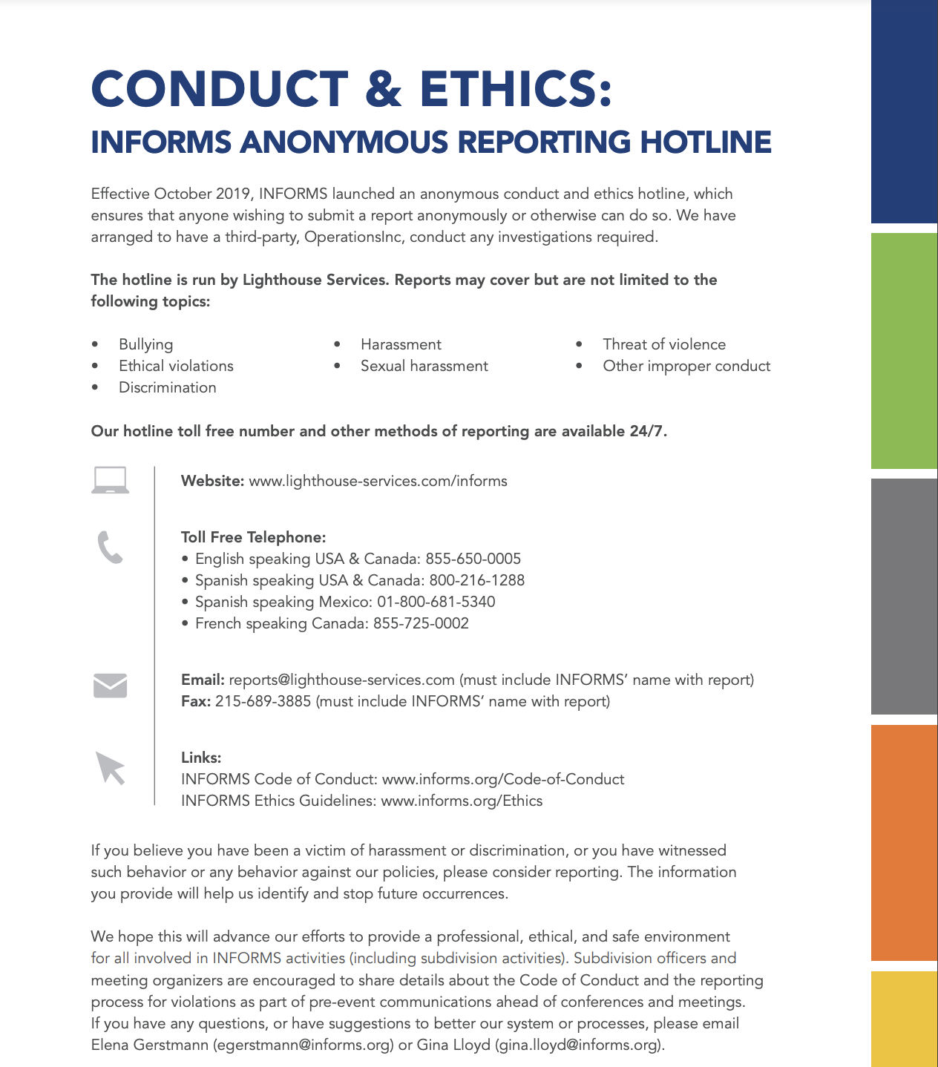

Current code of conduct can be seen https://www.informs.org/About-INFORMS/Governance/INFORMS-Code-of-Conduct.
Staff is not covered by this Code of Conduct but must abide by substantially similar policies.
This policy is for INFORMS-related activities. Violations that may have occurred during a non-INFORMS-related setting should follow the rules of that setting. For example, misconduct between a professor and a student occurring at the university should follow the university’s code of conduct even if both individuals are INFORMS members.
If the report involves the current President, or if the President has a conflict of interest, the Executive Committee, absent the President, will replace the President in this process. If the report involves the Executive Director, or if the Executive Director has a conflict of interest, the Executive Committee will replace the Executive Director in this process.
If a secondary policy exists for a certain area (for example, Fellows Revocation Policy, INFORMS Guidelines for Copyright & Plagiarism), a recommendation will be made to be entity.
The Immediate Past President or President-Elect may be asked to shepherd this appeal process if the President led the initial investigation. Timing of presidential terms will need to be considered. The aim is to ask a President who did not lead the investigation to lead the appeal.

