Directions to The MITRE Corporation—Bedford, MA

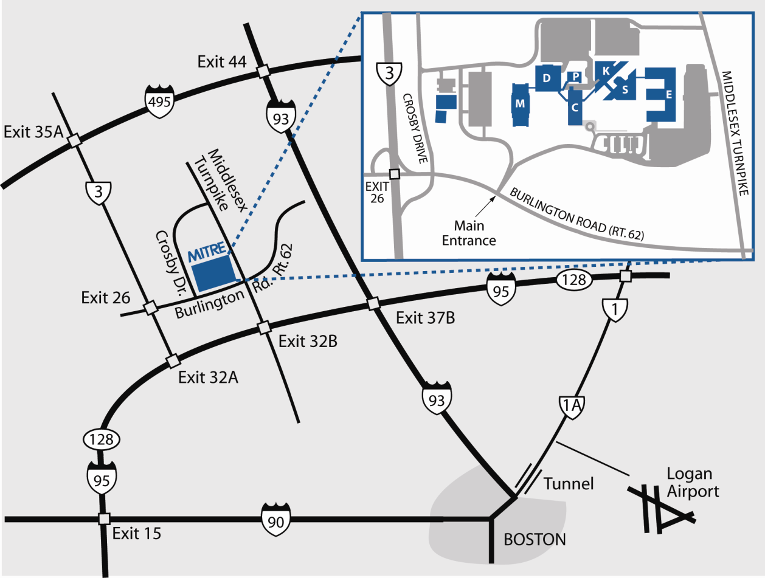

MITRE Bedford Complex
202 Burlington Rd. (Rt. 62)
Bedford, MA 01730-1420
(781) 271-2000

From New Hampshire to MITRE Complex
1. Take Route 3 South to Exit 26 (Route 62)
2. Turn Left on Route 62. It is a short distance to MITRE entrance on left--watch for building
directories on MITRE grounds.

From Manchester Airport (NH) to MITRE Complex
1. Start out going West on Airport Rd. toward parking
2. Turn slight right onto Brown Ave/NH-3A
3. Merge onto NH-101 West via the ramp on the left toward Bedford/Nashua
4. Take the Everett Turnpike South exit toward Merrimack/Nashua
5. Merge onto Everett Turnpike (toll road)
6. Everett Turnpike becomes US-3 South
7. Take exit 26 (Route 62) toward Bedford/Burlington
8. Turn Left onto (Route 62) Burlington Road
9. At second set of traffic lights, turn left at MITRE Bedford Campus entrance--watch for building directories on MITRE grounds.

Logan Airport to MITRE Complex
1. Exit airport towards Route 1A South/Sumner Tunnel (I-93) Boston.
2. Proceed through tunnel towards Storrow Drive (I-93 North).
3. Take I-93 North eleven miles to Exit 37B (Route 128 (I-95) South).
4. Take Route 128 (I-95) South six miles to Exit 32A.
5. Take Exit 32A, and proceed on Route 3 North.
6. Take Route 3 North for two miles to Exit 26 (Route 62).
7. Bear right on Route 62.
8. Take Route 62 a short distance to the MITRE entrance on left--watch for building directories on MITRE grounds.

If Diverted onto Route 1 A
1. Proceed North on Route 1A.
2. At traffic circle, take Route 60.
3. Follow straight through next traffic circle.
4. At third circle, take Route 1 North.
5. Proceed South on Route 95/128.
- Follow directions 4-7 above.

Bedford Campus Buildings & Parking

