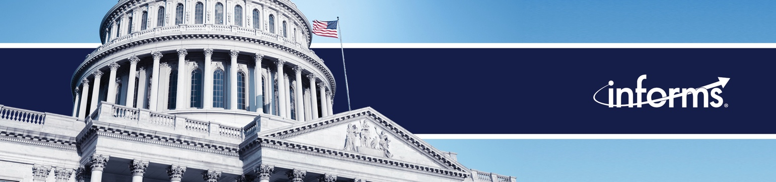

Weekly News Update: 3/13/23

Some great follow up opportunities this week. Original content by INFORMS in the form of press release and audio content has created a buzz among reporters, resulting in them reaching out for more information. This happened with the Dating News outlet opportunity on a recent audio content release focused on human trafficking done with Nickolas Freeman. Likewise, an opinion editorial from Sheldon Jacobson resulted in an interview with NBC Chicago on daylight savings time. Zachary Collier got a byline in a trade publication, Risk & Insurance, on supply chains and microelectronics.

Why Supply Chain Trust is So Crucial to the Microelectronics Industry  March 8, 2023  Zachary Collier | Human Trafficking: Informs.org Contributors Share Warning Signs to Look Out For Online  March 9, 2023  Nickolas Freeman
Sleep Experts Share Tips As Daylight Saving Time Begins This Weekend
March 10, 2023
Sheldon Jacobson

Members in the News

From lab to market, bio-based products are gaining momentum  March 4, 2023  Rob Handfield | Offer PreCheck for free to optimize TSA security  March 9, 2023  Sheldon Jacobson
Sheldon Jacobson: Offering Precheck for free to boost the number of vetted flyers would optimize TSA security  March 9, 2023  Sheldon Jacobson | Offering Precheck for free to boost the number of vetted flyers would optimize TSA security  March 9, 2023  Sheldon Jacobson
You might not know if your blender will kill you  March 9, 2023  George Ball | We Should ‘Split the Difference' When it Comes to Time Changes, Professor Says  March 10, 2023  Sheldon Jacobson
Jacobson: Free precheck would ultimately enhance TSA security
March 12, 2023
Sheldon Jacobson

PRESIDENT OF KYIV SCHOOL OF ECONOMICS VISITS UMASS AMHERST

PRESIDENT OF KYIV SCHOOL OF ECONOMICS VISITS
Press Releases

3/8: Do Consumers Care about GMO Labeling When Making Buying Decisions?

3/13: New Audio Available for Media Use: College Transfer Portal Likely to Have an Impact on Bracketology This Year

