Call for Papers

Special Issue on OpsFinTech (Interface of Operations, Finance and Technology)

Submission Deadline: September 1st, 2020

Guest Editors:
Dan A. Iancu, Stanford Graduate School of Business and INSEAD (daniancu@stanford.edu)
S. Alex Yang, London Business School and University of Hong Kong (sayang@london.edu)

Recent advances in technology such as analytics and AI, cloud computing and blockchain have enabled more efficient and transparent physical, information and financial flows across individuals, firms and organizations. These technological developments have also profoundly altered the connections between operations and finance: they have fueled innovative financial products and services that rely on extensive operational data, they have given rise to new business models aimed at directly improving operational performance by alleviating financial frictions, and they have disrupted traditional processes in the delivery of financial services, leading to a wide range of new operational challenges and opportunities.

Motivated by these observations, the current special issue aims to expand the boundaries of research at the intersection of operations, finance and technology, an area which we call OpsFinTech.

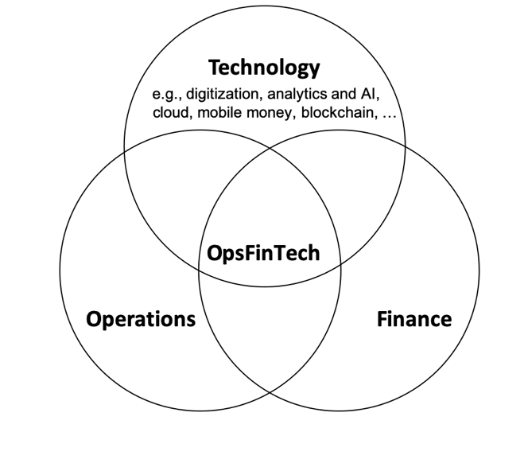
We welcome papers that rely on a variety of methodologies including analytical, empirical and experimental methods. We are open to papers that explore various research questions at this interface, including but not limited to:
- The role of technology in coordinating material and financial flows within firms and value chains
- Innovations in manufacturing and services enabled by technology-driven financing models such as crowdfunding, peer-to-peer lending, initial coin offerings, etc.
- Operational challenges in new business models enabled by technology such as mobile payments, Robo-advising, budgeting apps, etc.
- Using technology and operational innovations to improve financial inclusion and further sustainable development goals (e.g., providing novel financial solutions in emerging markets by enhancing operational transparency and value chain integrity, reducing environmental footprints, improving service design and delivery, etc.)
- Designing innovative products and services for risk management (e.g., relying on technology to design insurance products).

Authors can, but are not required to, send a short description of no more than one page of their project to the co-editors if they have questions about fit with respect to the special issue. Authors are also encouraged to submit their papers earlier than the deadline.

Proposed Timeline and Process
- Deadline for submission: September 1, 2020
- First-round decision and feedback: March 1, 2021
- Second-round submission (for those papers invited to revise): July 1, 2021
- Final decisions (subject to minor revisions): November 1, 2021

